Schedule

Tuesday, April 27

9:00 -10:15 a.m. Presentation:
The Transformative Impact of Coaching

10:30-12:00 p.m. Workshop Session I

2:00 – 5:00 p.m. COM and CPM Gatherings with National Staff Manuel Silva-Esterrich & Tim Cargal

6:00-8:00 p.m. LeaderWise Candidate Assessments Workshop

Wednesday, April 28

9:00 -11:30 a.m. Presentation & Demo: Coaching for Leadership Effectiveness

1:30-3:00 p.m. Workshop Session II

3:15-4:30 p.m. Presentation: The Supervisory Application of Coaching Emphasis

4:30-5:00 p.m. Board of Pensions Update & Closing Comments

Registration

Due to the virtual nature of this event, there is no cost or limit to the number of participants from each presbytery. We do ask that each participant register at:
https://synod-of-lakes-and-prairies.events.idloom.com/leadership-summit-2021

If you have questions about registration contact either Deb DeMeester or Gretchen Milloy at the Synod office by phone (800-328-1880, ext. 202 or 207)
or email ddemeester@lakesandprairies.org or gmilloy@lakesandprairies.org

If you would prefer to register by phone, please call Gretchen Milloy at 800-328-1880, ext. 202.

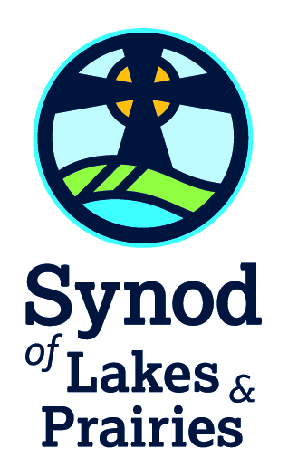

Synod of Lakes and Prairies

Leadership Summit

Coaching as Paradigm for Working with Congregations, Pastoral Leaders and Candidates



April 27-28, 2021

A Virtual Event for members of presbytery COMs, CPMs (or the equivalents) and other presbytery leaders interested in exploring ways to better support pastoral leaders and congregations.
Focus of Summit

This Leadership Summit will explore coaching for accompanying congregations through discernment as well as crisis or conflict. Many pastors have found coaching to be a tremendous gift in achieving their potential. The Synod has invested in training 19 coaches who are available to individuals, committees, and congregations.

Coaching provides a different paradigm for working with people and congregations. Approaching situations from a holistic, rather than problematic, perspective invites participants to not only greater effectiveness but also greater wholeness. It taps into the resourcefulness, creativity and values of people and ways to bring their inner and outer worlds into alignment.

“Through the coaching partnership, people can build capacity, expand possibilities and achieve greater fulfillment and success.”

Keynote Speaker

Okokon Udo

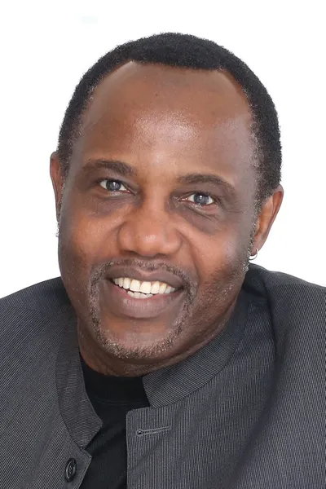
Okokon Udo is an international change management and leadership consultant, a certified executive coach, process facilitator, and master trainer with over 30 years of experience in organizational effectiveness, leadership and team development. He has served on the faculty of the Coaches Training Institute delivering their ten-month transformational leadership program in North America, Europe and Asia, St. Mary’s University, University of St. Thomas and Northwestern Health Sciences University. He is also a staff associate for LeaderWise. He brings a passion for mentoring young professionals and immigrants, is a sports enthusiast, an avid photographer, actor and world traveler.

Workshop Topics

♦ Coaching and Visioning Teams: One Presbytery’s Experience, Kevin Veldhuisen

♦ CRE/MWS Processes: Trends, Expectations, Ideas, Tim Cargal

♦ Dynamics of the Long Pastorate: What COMs Need to Know, Terry Purvis-Smith

♦ Leading with Discernment: Tools to Adapt for Congregations, Deb DeMeester
♦ Transforming Church Conflict, Theresa Latini
♦ Having Hard Conversations: Dealing with Bullies, Back-stabbers & Other Belligerent People, Rachel Yates
♦ Realistic Part-Time Calls: A tool for defining such a call and applicable benefits, Linda Kuhn & Dave King
♦ Examining Policies with an Eye Toward Equity, TBD
♦ Gender and Leadership in the PCUSA: What Have We Learned and Its Impact on Preparation, TBD

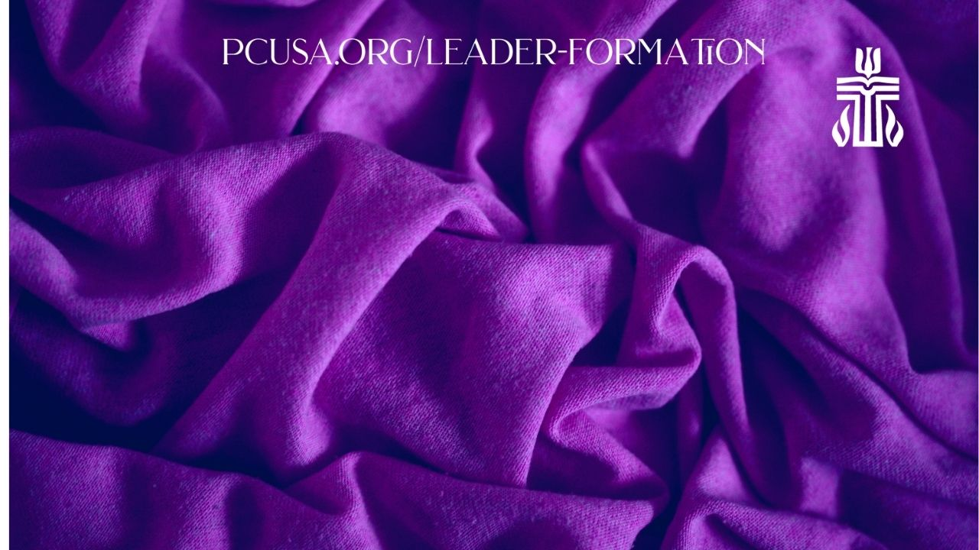

Workshop Leaders

Tim Cargal
Ministry Preparation and Support, Mid Council Ministries of the Office of the GA
Deb DeMeester
Director of Leadership Development, Synod
Ken Green
Board of Pensions Church Consultant
Dave King & Linda Kuhn
Sandbur Consulting,
Theresa Latini
Executive Director, Mount Olivet Conference & Retreat Center
Terry Purvis-Smith
Interim Pastor, Iowa City, IA
Manuel Silva-Esterrich
Manager for Call Process Support, Mid Council Ministries of the Office of the GA
Kevin Veldhuisen
Stated Clerk & Mission Coordinator, Presbytery of South Dakota
Rachel Yates
Executive Presbyter, Milwaukee

Others are in process!! A full description of workshops and leaders will be forthcoming.

Coaching for Transformation: Pathways to Ignite Personal and Social Change. 2nd Edition, p. 4.

